Disease : Hypoglycemia

Protein: P01275

Tools Used : PyMOL , BLAST tool

Data:

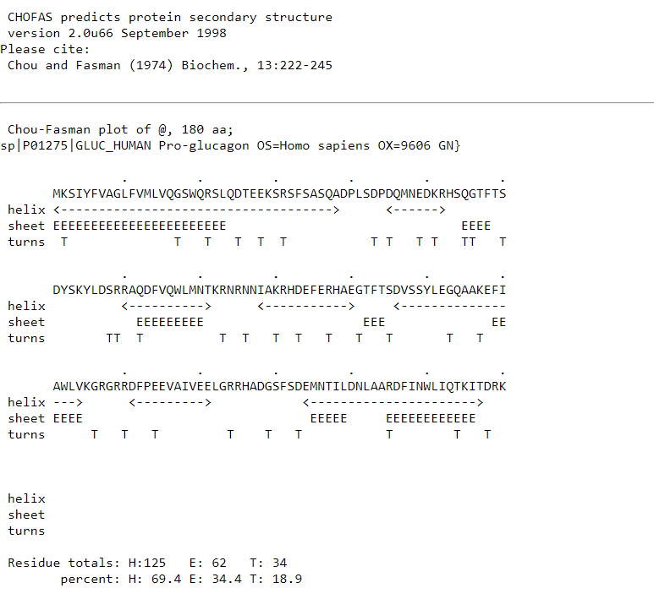

By <https://fasta.bioch.virginia.edu/fasta_www2/fasta_www.cgi?rm=misc1&pgm=cho>

**Useful links:**

<https://www.ncbi.nlm.nih.gov/Structure/pdb/2QKH>

<https://www.ncbi.nlm.nih.gov/protein/?term=Homo+sapiens+Glucagon>

<https://www.youtube.com/watch?v=tkxNuTADMWg>

### **Insulin Protein Code**

The PDB code for human insulin is **1MZ7**. This structure includes the insulin hexamer, which is the form insulin takes in storage.

### **Simulating Insulin and Its Effects in PyMOL**

To demonstrate how insulin leads to hypoglycemia in PyMOL, follow these steps:

#### **1. Load the Insulin Structure**

* Download the PDB file for insulin (1MZ7).

Open PyMOL and load the structure:  
lua  
Copy code  
load path/to/1MZ7.pdb

#### **2. Visualize the Structure**

Use commands to display the structure clearly:  
css  
Copy code  
show sticks

color cyan, all

#### **3. Identify Key Binding Sites**

Identify and highlight the binding site for the insulin receptor:  
bash  
Copy code  
show spheres, (resi X) # Replace X with relevant residue numbers

#### **4. Modeling Interaction with the Insulin Receptor**

If you have the structure of the insulin receptor (e.g., PDB code for the insulin receptor is **4E40**), load it in PyMOL as well:  
lua  
Copy code  
load path/to/4E40.pdb

#### **5. Simulate Insulin Binding**

Position insulin near the receptor to illustrate binding:  
bash  
Copy code  
orient # Adjust the view to see both proteins clearly

#### **6. Explain Mechanism of Hypoglycemia**

* Create a visual representation of how insulin lowers blood glucose levels:
  + Use arrows or labels to indicate:
    - Increased glucose uptake by cells (especially in muscle and fat tissue).
    - Increased glycolysis and decreased gluconeogenesis in the liver.
  + Highlight how excessive insulin can lead to hypoglycemia by pushing glucose into cells and reducing circulating glucose levels.

#### **7. Dynamic Simulation (Optional)**

* If you want to simulate the dynamic binding or activity, consider exporting the structure for molecular dynamics simulations using tools like GROMACS.

#### **8. Save Your Work**

Save your PyMOL session:  
Copy code  
save insulin_hypoglycemia_simulation.pse

### **Conclusion**

By loading insulin and possibly its receptor, visualizing their interaction, and illustrating the pathway leading to increased glucose uptake, you can effectively demonstrate how insulin leads to hypoglycemia in PyMOL. If you need more specific guidance on any step, let me know!